DATA ANALYTICS POWERED BY TABTEAU

**PROJECT TITLE**

**SUSCRIBERS GALORE : EXPLORING WORLD’S TOP YOUTUBE CHANNELS**

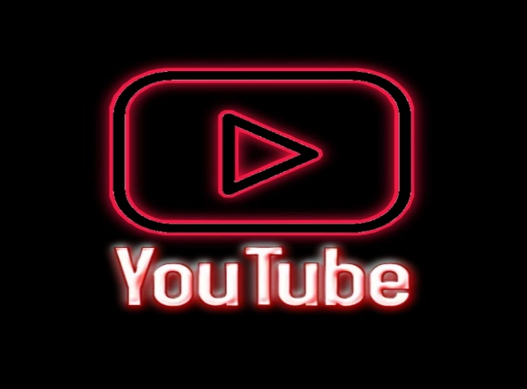

**TEAM ID :**NM2023TMID07844

**TEAM LEADER :** ASHIKA.S

**TEAM MEMBERS:**RAJISHA.P

RAGINI.P

RESHMA.S

BRINTHA.M

**PROJECT REPORT**

**1.INTRODUCTION**

* OVERVIEW
* PURPOSE

**2.PROBLEM DEFINITION AND DESIGN THINKING**

* EMPATHY MAP
* IDEATION AND BRAIN STORMING MAP

**3.RESULT**

**4. ADVANTAGES AND** **DISADVANTAGES**

**5.APPLICATIONS**

**6.CONCLUSION**

**7.FUTURE SCOPE**

**8.PERFORMANCE TESTING**

**SUBSCRIBERS GALORE: EXPLORING WORLD’S TOP YOUTUBE** **CHANNELS**

**1.INTRODUCTION**

**1.1PROJECT DESCRIPTION**

Exploring world’s top youtube channels provides information on the history, criteria, and ranking of the most subscribed youtube channels. You can find out which channel have held the top spot overtime, which languages and content categories are dominant and which channels have reached certain milestones. You can sort the channels by various metrics such as subscribers, views, uploads and grade. You can also filter the channels by country, category and data range.

**1.2PURPOSE**

To learn about the trends and preferences of the global youtube audience and how they differ across regions, languages and genres. To discover new and diverse content that can entertain, educate or inspire the user and broaden their perspective. To analyse the strategies and techniques of the successful youtube creators and how they engage with their fans and attract new subscribers. To compare and contrast the different styles and formats of the youtube videos and how they affect the viewers’ reaction and feedback. To find potential collaborators or partners for creating or promoting youtube contents.

**2.PROBLEM DEFINITION AND DESIGN THINKING**

As youtube is the world wide search engine, we find it difficult to find good contents. There are more and more posts that contain similar contents and we are struggling to get best out of them.

**2.1 EMPATHY MAP**

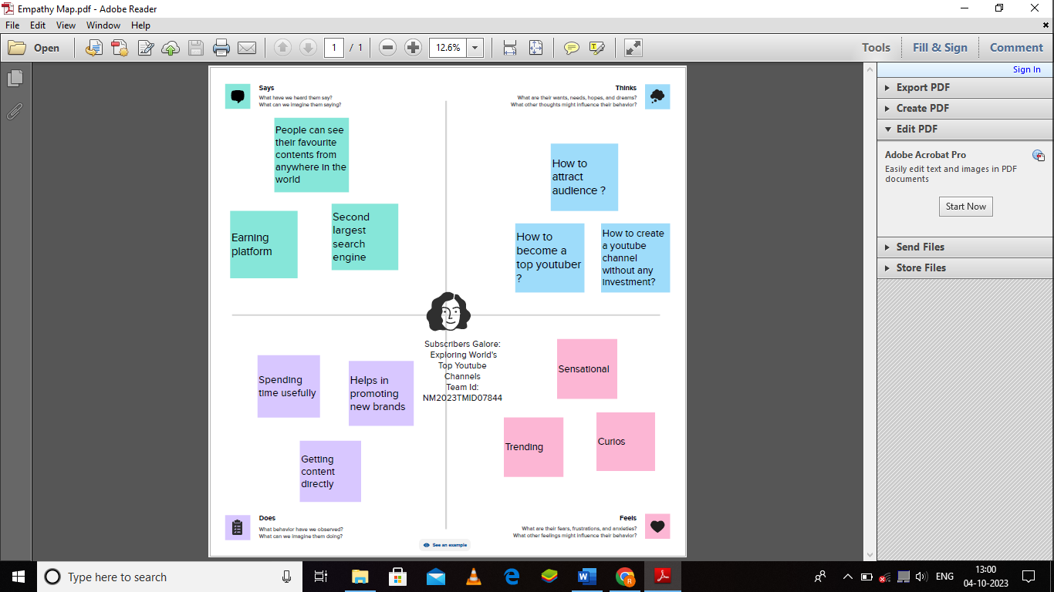

**2.2.IDEATION AND BRAINSTORMING MAP**

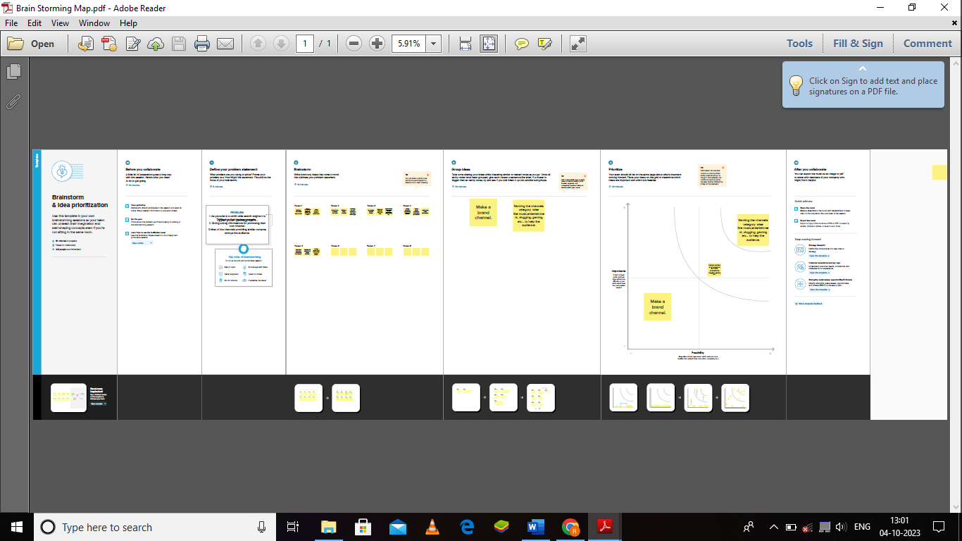

3.RESULT

**DASHBOARDS**

DASHBOARD 1

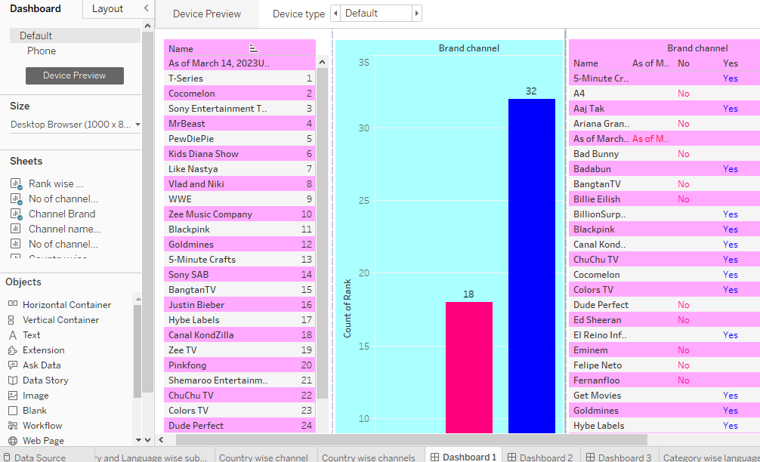

DASHBOARD 2

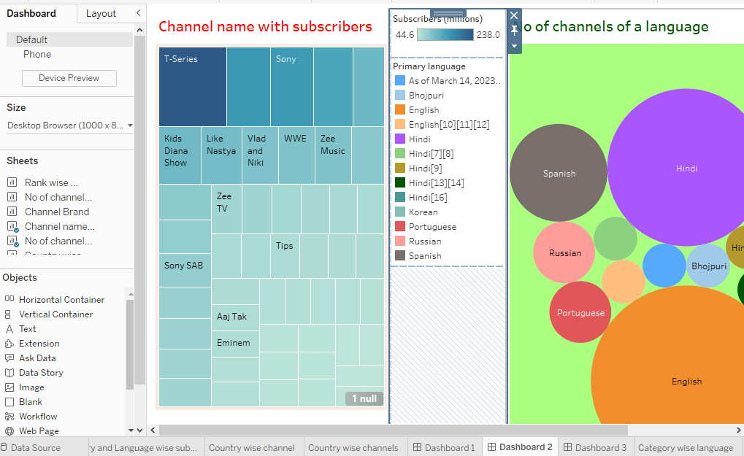

DASHBOARD 3

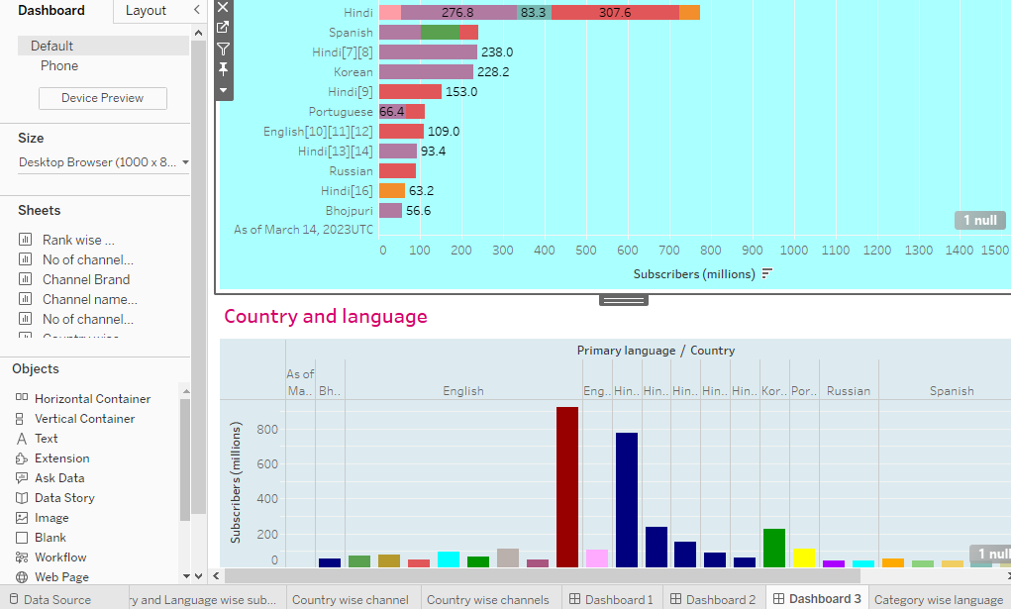

DASHBOARD 4

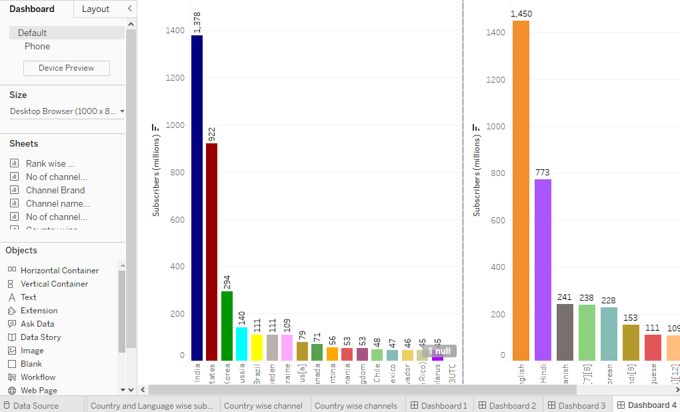

**STORY**

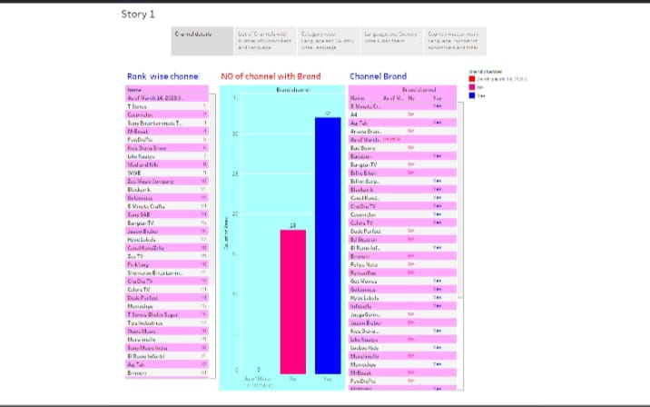

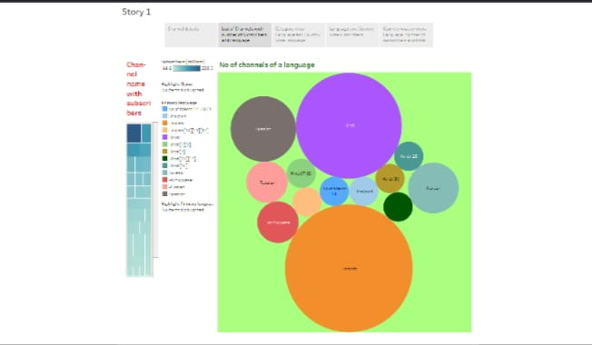

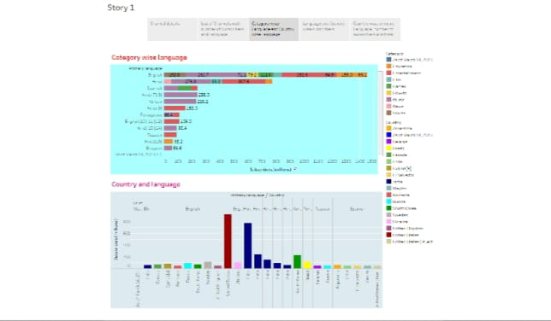

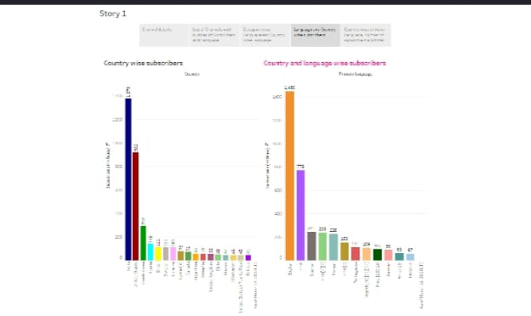

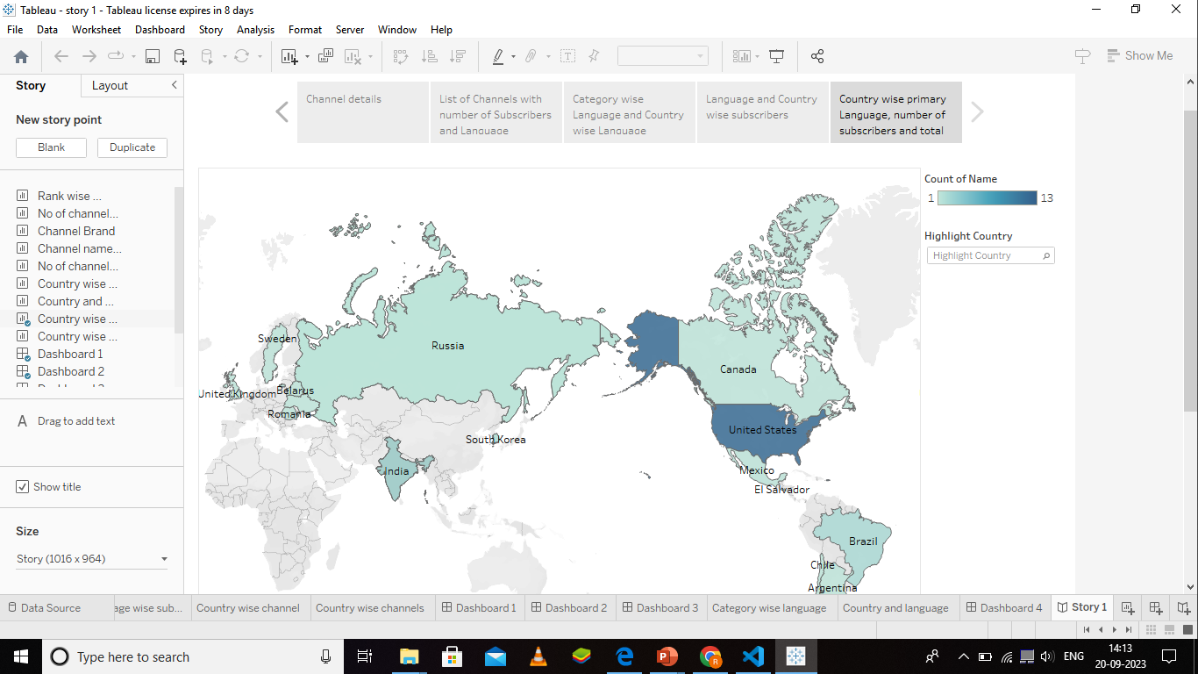

**4.ADVANTAGES AND DISADVANTAGES**

ADVANTAGES

* You can learn new things as your wish.
* You can learn from the best practices and strategies of successful content creators, such as how they engage with their audience, optimize their videos for SEO, and monetize their channel.
* You can discover new and diverse topics, genres, and perspectives that might interest you or inspire you to create your own content.
* You can enjoy high-quality entertainment and education that is tailored to your preferences and needs.
* You can connect with a global community of fans and creators who share your passions and interests.
* You can support your favorite channels and help them grow by subscribing, liking, commenting, and sharing their videos.

DISADVANTAGES

* It may lower your self-esteem and confidence. When you see how successful, popular, and influential some YouTube channels are, you may feel inadequate, inferior, or discouraged. You may start to doubt your own abilities, skills, and value. You may think that you can never achieve what they have achieved, or that you are not good enough to compete with them. This can affect your motivation, performance, and happiness.
* It may limit your creativity and originality. When you explore world’s top YouTube channels, you may be tempted to copy or imitate their style, format, or content. You may lose your own voice, identity, and uniqueness. You may become dependent on external sources for ideas and inspiration, rather than relying on your own imagination and innovation. This can reduce your competitive edge, differentiation, and growth potential.
* It may distract you from your own goals and vision.

**APPLICATIONS**

**Entertainment:** YouTube offers a variety of content for entertainment, such as music videos, comedy sketches, movie trailers, gaming videos, and more. You can alsowatch live streams of events, concerts, sports, and gaming. YouTube also has original shows and movies that you can watch with a YouTube Premium subscription.

**Education:** YouTube is a great source of learning and information, as you can find videos on topics such as science, history, math, languages, arts, and more. You can also watch tutorials, lectures, documentaries, and educational channels that can help you with your studies or hobbies.

**Communication**: YouTube allows you to communicate with other people through comments, posts, stories, and live chats. You can also create your own videos and share them with your friends, family, or the world. You can express yourself, showcase your talents, or promote your ideas through YouTube.

**Marketing**: YouTube is a powerful tool for marketing and advertising, as you can reach a large and diverse audience with your products or services. You can also collaborate with other creators or sponsors to create sponsored content or ads. YouTube also providesanalytics and insights that can help you optimize your marketing strategy.

**CONCLUSION**

* YouTube is the world’s largest video-sharing platform, where users can upload, watch, share, comment, and subscribe to videos of various genres and topics.
* YouTube was founded in 2005 by three former PayPal employees, and was acquired by Google in 2006.
* YouTube has over 2 billion monthly active users, who watch over a billion hours of video every day.
* YouTube also offers various features and services, such as YouTube Music, YouTube Premium, YouTube TV, YouTube Kids, YouTube Shorts, YouTube Gaming, YouTube Studio, and more.

**7.FUTURE SCOPE**

YouTube will become more than just a video platform, but an all-encompassing entertainment service that includes games, music, virtual reality, and live sports. YouTube will leverage its large user base, its parent company Google’s technology, and its partnerships with content creators and media corporations to offer diverse and immersive experiences toits audience.

YouTube will become smarter and more personalized, using artificial intelligence and machine learning to understand the preferences, interests, and needs of each user. YouTube will beable to recommend videos, music, games, and other content that match the user’s taste, mood, and context. YouTube will also be able to create customized summaries of long videos, such as documentaries, movies, or lectures, using video summarization techniques.

YouTube will become more social and interactive, enabling users to co-view videos with their friends and family, chat with other viewers and creators, and participate in live events and activities. YouTube will also foster a sense of community and belonging among its users, who will be able to share their opinions, feedback, and creativity with others. YouTube will also support more forms of expression and communication, such as voice recognition, gestures, and emotions.

**8.PERFORMANCE TESTING**

